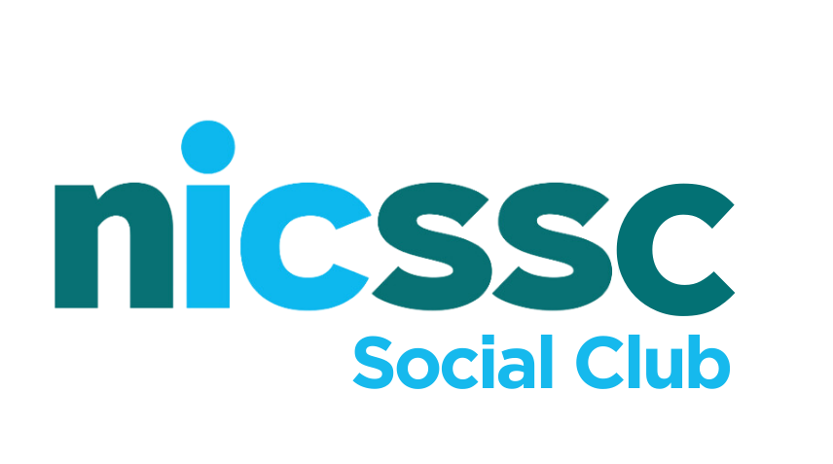

January 2025

Election of representatives to the NICS Social Club 2025-2026

In preparation for the AGM which will be held on Wednesday 23rd April 2025 at 7.30pm, I am writing to invite nominations to the Management Committee for six positions of which not less than three positions shall be elected from nominees of the Pavilion based sports clubs.

The Management Committee is keen to ensure that its membership is fully represented in the business of the Social Club and would encourage members and clubs to take advantage of this opportunity to nominate a member who is prepared to reflect their views on the Committee.

The arrangements for nomination are as follows: -

- The term of office will be for 1 year i.e. from April 2025 – April 2026

- Nominations should be made on the attached form and sent to Kieran Devlin at the Pavilion, Stormont or email kieran.devlin@nicssa.co.uk to arrive no later than 5:00 pm on Friday 4th April 2025.

- Should there be more nominations than available positions then a vote will take place on the night of the AGM to determine the six representatives to sit on the Management Committee.

Should you have any queries please do not hesitate to contact Kieran Devlin on (028) 9052 2690

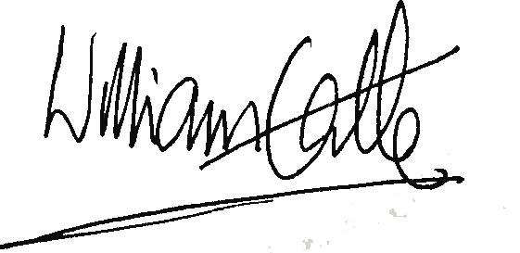
William Gamble (Billy)
Chairman
NICS Social Club

NICS Social Club
Election of representative to the NICS Social Club Management Committee
(2025-2026)
NOMINATION FORM
Nominations for election of representatives to the
NICS Social Club Management Committee
(2025-2026)
Affiliated Club:
Title: Mr/Mrs/Miss/Ms/Other
Name: (IN BLOCK CAPITALS)
Contact Address:
Postcode:
Daytime Telephone:
Email Address:
Membership Number:
Proposer: (IN BLOCK CAPITALS)
Signature:
Membership Number
Seconder: (IN BLOCK CAPITALS)
Signature:
Membership Number:
Please complete this form in full and submit it to Kieran Devlin no later than 5:00 pm on Friday 4th April 2025.

